Submitted by: Diana Clonch, DW Clonch, LLC
March 1, 2018

Paving The Way: Permeable Pavements and Winter Maintenance

Permeable pavements, in a variety of types, are becoming more common place among the types of surfaces requiring winter maintenance services. In particular, low volume streets, parking areas, driveways, and foot paths are being constructed of permeable materials as a measure to reduce storm water runoff and improved overall water quality. As permeable pavements are of a different design than the typical impermeable asphalt and concrete surfaces, maintenance options, including winter maintenance, requires treatments options that are likewise different.
Permeable pavements, while not necessarily a new concept, have evolved in design, composition and popularity over the last few years. While compacted gravel surfaces, turf and paver bricks have long been used, the advent of porous asphalt and pervious concrete are noted as making an appearance in the 1970’s and have become increasing popular due to their excellent storm water management properties and as a best practice to help meet National Pollutant Discharge Elimination Permitting requirements and control flooding (Kevern, 2011).

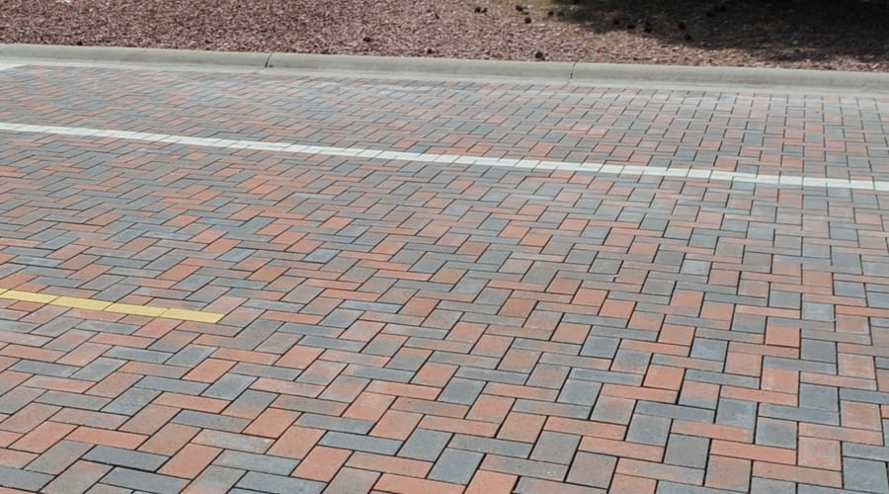

Permeable pavements are designed to allow water (rain or snowmelt) to seep through voids in the surface material into the base material which is designed for temporary storage and further filtration thus slowing down the runoff and removing solids and contaminants before the water eventually enters the ground and ground water supply. A typical cross-section for a permeable pavement includes the porous or pervious surface (asphalt, concrete, pavers) placed atop various levels and gradations of gravel sub-base which may or may not include geotextile fabric and drain tile. The surface course of asphalt or concrete has a high percentage of voids allowing water to filter through to the base and to not collect, pond or run or run across the surface.
In appearance and texture the surface of pervious asphalt is somewhat coarser but still resembles a traditional asphalt surface. The surface of porous concrete is coarser, with larger sized aggregate exposed and not as smooth as traditional impervious concrete surfaces. The PA Stormwater BMP Manual 2006 notes that pervious asphalt and concrete surfaces provide better traction for walking paths in rain or snow conditions. Other studies likewise report higher traction values during winter months for pervious surfaces compared to impervious.
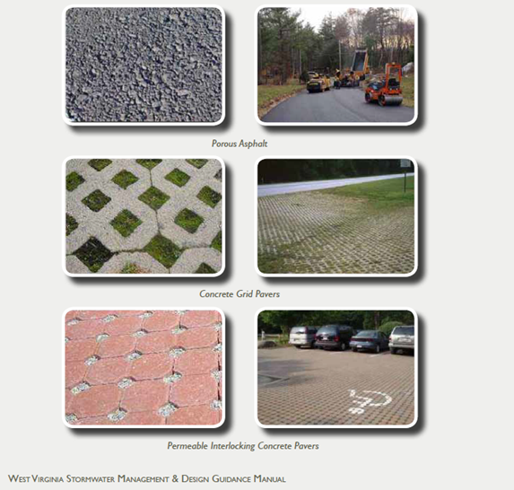

Permeable pavements are reported to heat and cool differently from traditional pavement types due in large part to the higher percentage of voids thus having the tendency to more closely follow air temperature trends. In addition, not only can the water as retained in the underlying gravel base can impact temperatures but as noted in the PA Stormwater BMP Manual 2006, the underlying stone bed tends to absorb and retain heat so that freezing rain and snow melt faster on pervious pavement.
While there remains some debate within the industry regarding the use of such pavements (depending upon design) for high volume areas due primarily to traffic and/or contaminant level loading issues, ample data exists to show these systems are performing well in lower volume locations (parking lots, low volume roads, driveways, footpaths). As research and practical application have proven the many benefits of permeable pavements associated with storm water management, pollution control and pavement durability and performance it is most likely the installation trend will continue upward.
Design criteria for permeable pavements seems well defined with guidance available through professional organizations, various State departments and industry experts. On the other hand, maintenance of the pavements, especially winter maintenance, seems to be an area for debate and ongoing discovery. Depending upon the type of permeable pavement in question and the source of information, it is not uncommon to find conflicting recommendations.
Concerns regarding issues with winter maintenance tend to focus on not restricting filtration properties and preserving the integrity of the pavement. Understanding the intended design of these surfaces, filtering of water, fully explains the need to not restrict the voids in the pavement with applications of abrasives such as sand. Using sand or other abrasive materials clogs the voids and prohibits filtration. Maintaining the integrity of the permeable pavement also requires attention to plowing methods to not destroy the coarse surface (or in some designs a reinforced surface) by aggressive plowing and not overusing chemicals that may escalate pavement deterioration.
Last but not least, permeable pavements required attention to deicing chemical application rates. As these pavements heat and cool differently than their impermeable counterparts (Kevern 2011), and eliminate standing and ponding water, deicing chemical application rates should also vary. Depending upon specific impermeable pavement type, research and field studies site sizeable reductions in typical chemical applications required to meet desired levels of service. Porous asphalt has been found to require up to 70% less chemical and more over the duration of a winter season while still achieving desired levels of service. Porous concrete, when first adequately plowed following an event, also requires less chemical. Color differences among surfaces may also impact temperatures and conversely the amount of required deicer.
In addition to the heating and cooling properties of the impermeable pavements impacting the amount of needed deicer, the reduction in the overall amount of chemicals required throughout the season is attributed to the impervious system’s ability to filter away the surface water before it can refreeze. Thus, eliminating the need for reapplication. While initial applications following an event may be comparable to that of traditional surfaces, the need for reapplication is greatly reduced if not eliminate.
Chemical applications on impervious surfaces may show a longer residual as moisture on the surfaces quickly drains away without melting the solids. However, once melting does occur the dissolved solids in the water will drain through the system and into the ground water. Depending upon the imperviable material type, asphalt or concrete, some within the industry promote not using, or severely restricted use, of common deicing chemicals containing chlorides and/or acetates (especially on concrete). Numerous references can be found suggesting such when performing winter maintenance on pervious concrete, including elimination of anti-icing treatments (National Ready Mixed Concrete Association, Pervious Concrete Pavement Maintenance and Operations Guide).
Where a deicing chemical, such as rock salt, is used in winter maintenance operations for treating impermeable surfaces, it is consistently reported that a much lower amount of material is required to maintain these pavements at acceptable levels as compared to the traditional impervious surfaces. The PA Stormwater BMP Manual 2006 (Chapter 6, Page 19) notes “Winter maintenance for a pervious parking lot may be necessary but is usually less intensive than that required for a standard impervious surface. By its very nature, a pervious pavement system with subsurface aggregate bed has superior snow melting characteristics than standard pavement. The underlying stone bed tends to absorb and retain heat so that freezing rain and snow melt faster on pervious pavement. Therefore, ice and light snow accumulation are generally not as problematic. However, snow will accumulate during heavier storms. Abrasives such as sand or cinders should not be applied on or adjacent to the pervious pavement. Snow plowing is fine, provided it is done carefully (i.e. by setting the blade slightly higher than usual, about an inch). Salt is acceptable for use as a deicer on the pervious pavement, though nontoxic, organic deicers, …………….. are preferable.”
The major “take-away” from the available information as related to performing winter maintenance on permeable surfaces includes recognition that the pavement design is different than traditional impervious services and therefore requires adjustment in treatment type. While prescribed winter maintenance practices for various impermeable surface types continue evolving through ongoing research and practical application, there are some general guidelines for those currently providing snow and ice removal on such surfaces. In review of available best practices as currently established within the industry by various State road departments, industry organizations and product providers, a few highlights include:
- Adequate plowing after storm events to remove snow and ice
- Plowing in a method to not damage the surface (especially porous concrete and decorative pavers) such as use of polyurethane blades, rubber blades, blades with a wide footprint, slightly raised blades, and avoiding heavy down pressure. Or other mechanical removal such as a snow blower. Skid steers and back dragging are not recommended on pervious concrete.
- Avoid over plowing - recognition by the operator that after plowing a pervious concrete surface that snow will still be present in the surface voids
- Avoid use of sand or other abrasives to avoid clogging the voids in the system
- Apply chemicals suitable for the event and pavement type and adjust amounts accordingly
- Adjust chemicals as required by site specific characteristics such as type of surface, color of surface, amount of shade
- Apply chemicals to control snow and ice not removed by plowing
- Do not store snow on pervious pavements to avoid drainage of contaminates into the system
Depending upon the type of pavement being serviced, numerous references exist to assist in determining how to best provide winter maintenance. In a nutshell guidance recommends reduced chemical application and mechanical removal. A quick Google search on the type of pavement being maintained will produce numerous references and guidelines and help develop a footprint for moving forward with a productive and successful approach. As ongoing research continues additional guidance will be forthcoming….stay posted for the latest developments!

References
CTC & Associates Inc. (2012). Porous Asphalt Performance in Cold Regions. Report 2012-12TS. Minnesota Department of Transportation, St. Paul, Minn. Available online at www.dot.state.mn.us/research/TS/2012/201212TS.pdf
Federal Highway Administration, 2016. FHWA-HIF-16-004, Tech Brief, Permeable Concrete Pavements. Available online at https://www.fhwa.dot.gov/pavement/concrete/pubs/hif16004.pdf
Kevern, J.T., 2010. Operation and Maintenance of Pervious Concrete Pavements, Transportation Research Board, 11-0656, Washington DC. Available online at http://docs.trb.org/prp/11-0656.pdf
Lebens, M. (2012). Porous Asphalt Pavement Performance in Cold Regions. Report 2012-12. Minnesota Department of Transportation. St. Paul, Minn. Available online at www.dot.state.mn.us/research/documents/201212.pdf
National Ready Mix Concrete Association, Pervious Concrete Maintenance and Operations Guide, 2015. Available online at http://www.perviouspavement.org/downloads/pervious_maintenance_operations_guide.pdf
Pennsylvania Stormwater Best Management Practices Manual, Department of Environmental Protection, Bureau of Watershed Management, 2006. Available on line at http://pecpa.org/wp-content/uploads/Stormwater-BMP-Manual.pdf
UNHSC (2011). Regular Inspection and Maintenance Guidance for Porous Pavements. University of New Hampshire Stormwater Center, Durham, N.H. Available online at www.unh.edu/unhsc/sites/unh.edu.unhsc/files/UNHSC%
West Virginia Stormwater Management and Design Guidance Manual, WV Department of Environmental Protection, 2012. Available online at http://dep.wv.gov/WWE/Programs/stormwater/MS4/Pages/StormwaterManagementDesignandGuidanceManual.aspx

